41.2: a) 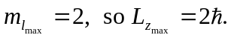 b) 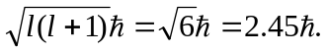 c) The angle is arccos 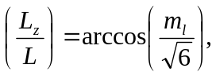 and the angles are, for
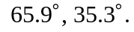 The angle corresponding to 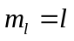 will always be larger for larger

